Eng 407B, Technical Writing Students
UNLV Professional Writing
C/O Dr. Julie Staggers
Department of English
University of Nevada, Las Vegas
4505 Maryland Parkway, Box 455011
Las Vegas, NV 89154-5011

May 2, 2010

Scott Betts, President & CEO
Global Cash Access
3525 East Post Road
Suite 120
Las Vegas, NV 89120

RE: Final Recommendation Report

Dear Mr. Betts,

Please find enclosed a copy of our report detailing our recommendations for saving a considerable yearly sum on lighting costs while decreasing the company’s environmental impact.

Turn Off the Lights:

Recommendations to Promote Sustainable Business Practices

May 2, 2010

Prepared for Consultants Business Writing Instructor

Scott Betts Richard Wood Dr. Julie Staggers
President & CEO Jeffrey Hajibandeh University of Nevada, Las Vegas
Global Cash Access Antonia Connolly 4505 Maryland Parkway
Jennifer Smith Box 455011
Las Vegas, NV 89154-5011
Executive Summary

Finding a greener way to provide light for the employees of Global Cash Access (GCA) is the subject of this Sustainability Project, the purpose of which is to compile and report an analysis of alternative lighting sources. The team considered several criteria when deciding which lighting methods would potentially provide the highest benefit at the lowest amount of cost.

Criteria included:
- Cost
- Scheduling
- Hours of operation
- Environmental impact

Based on these criteria, the team agrees that re-wiring and adding additional individual switches provide the best solution for GCA. Allowing employees to adjust lighting on an as needed basis minimizes energy usage while also introducing little to no impact on productivity. The relatively low cost in making the proposed changes in addition to the year over year cost savings allows the company to make a solid financial decision while embracing a greener vision for the company’s energy consumption.
Due to differential costs charged for energy by Nevada Energy, savings will vary based on the time of year and time of day. We have calculated costs based on the maximum and minimum rates, and the savings if these measures are adopted will be between a minimum of $4,748.43 and a maximum of $16,539.62 annually.
Introduction 5
Background 5
Client Description 5
The Problem 5
Recommendations 6
1. Rewiring to: 6
1.1 Add individual light switches 6
1.2 Add motion sensors 8
Research 9
Methods and Findings 9
Hours of Operation 9
South Side: 9
North Side: 10
Current Fixtures 10
Wiring Layout 10
Current Costs 10
Potential Savings 12
Conclusion 13
List of Sources 14
Appendix: Detailed Cost Calculations of Proposed Zones 15

Introduction
Global Cash Access (GCA), a service provider for the gaming industry, has a Las Vegas office composed of two main building sections. Like any office building, it contains numerous fluorescent bulbs; however, these are operated by only one control for each main section. Despite the fact that large portions of the building are unoccupied during evenings and weekends, these lights are very rarely turned off. These circumstances present an obvious problem of waste and inefficiency with GCA's power consumption. The purpose of this report is to present recommendations designed to tackle this issue and to provide Global Cash Access with viable options to reduce their overall power consumption

Background
In the current economy, many companies are concerned with reducing overhead costs in order to offset loss of revenue. GCA has recently expressed an interest in reducing these costs to employees and asked employees for suggestions. Richard Wood, an employee in the help desk, has frequently in the past attempted to turn off the lights on the north side of the building when he arrives at midnight, but on almost every occasion there has been someone still working (usually only one person) who has needed to turn them back on. The initial impetus for this report was his desire to come up with a way for the company to save money on lighting and reduce overall power consumption.

Client Description
Global Cash Access (GCA) is the premier provider of cash access products for the gaming industry in the United States and the world. Established in the early 1970s, GCA provides products and services to over 1,100 gaming establishments worldwide, including all of the largest gaming companies in the United States. The company is headquartered in Las Vegas, Nevada.

The Problem
The current office layout, lighting plan, and the timing of employee hours are tremendously inefficient. Most of the lighting is very rarely turned off, even though there are portions of the building unoccupied from 5 or 6 PM until roughly 7 to 9 AM on weekdays, and unoccupied through the entire weekend. Often, one person working late (say, until midnight) will result in the lights for an entire side of the building being lit. In addition, it is rare for the last person in a section to turn off the lights, because it is difficult to tell if someone may be still working in another area. There are only two areas in the building with people working in them 24/7, and one of these (the help desk, where Richard works) already has separate light controls. The other area, the call center, is a fairly large area, occupying about 1/2 to 2/3 of that section of the building, but only a small section of that area is currently in use. These issues present tremendous opportunities for cost savings that are not only financially enticing but are also environmentally conscious.

Recommendations
After reviewing power usage habits and wiring plans, as well as researching electrical costs based on consumption with NV Energy, we have determined that a minor rewiring of the office is the best course of action to save money as well as decrease the electrical consumption of GCA.

Rewiring to:

1.1 Add individual light switches
The current wiring arrangement causes all of the lights in each section of the building to be turned on from only 1 switch. To mitigate excessive power consumption, zones have been created to divide up the current circuitry into more manageable areas.
Each lighting fixture operates at 96 watts. For each of these zones, a switch would be installed in a relevant and accessible area on the wall.
For the North side office in particular, seven equally sized and lit areas would allow for maximum control over individual areas while maintaining sufficient lighting for working conditions. Zones 1 through 5 would each contain 10 lighting fixtures, while zones 6 and 7 would contain 8 lighting fixtures.
For the South side, the zones are not equally sized, but the layout proposed in the diagram below should maximize the effectiveness of lighting by allowing areas to be lit only when in use.
In addition, an effort should be made to inform employees of the importance of turning off the lights when no longer using them. It must be the individual prerogative for each employee to be conscientious of their light usage and to minimize it where possible.
North Office Proposed Zones:
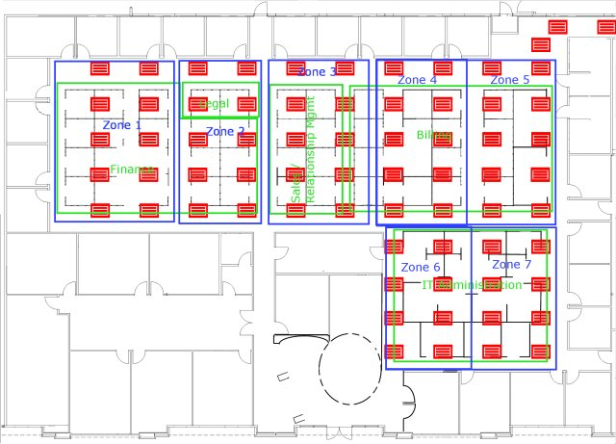

South Office Proposed Zones:
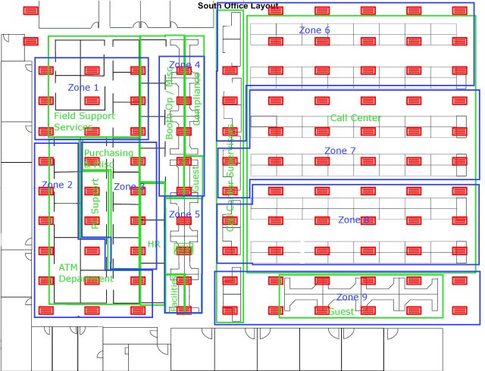

Add motion sensors
Motion sensors add an additional level of sensitivity in the efforts to reduce overall power consumption. In addition to the switches that are to be implemented for each of the zones, each of these can also be synchronized with a respective motion sensor. Outside of normal business hours, the motion sensors will take the place of individual initiative by ensuring that power in unoccupied zones would remain off until an employee trips its sensor. Motion sensors will only be effective if used in conjunction with manually operated switches.

Research
Our research consisted of:
- On-site inspections
- Evaluation of office layout
- Evaluation of wiring diagrams
- Internet searches

Methods and Findings

Hours of Operation
Richard conducted an informal survey to find out when people typically left for the day for each area / department. The survey was conducted by consulting with at least two people in each area and asking who was the earliest in and latest out on a regular basis. If available, those people would then be asked for their typical times in and out. The earliest-in and the latest-out times were used to generate the time frames below. In general, light will be needed in these departments / sections during all weekdays during these times.

South Side:
Call center **there is a large portion of the call center that isn't currently being used which can be dark 24x7 | 24 x 7
Facilities | 8:30 AM – 5:00 PM
ATM **section by facilities; right side in image | 8:00 AM – 6:00 PM
Compliance | 6:00 AM – 5:00 PM
Human Resources | 7:30 AM – 6:30 PM
Booth OP/Miscellaneous | 7:00 AM – 7:00 PM
Purchasing/Miscellaneous | 7:30 AM – 6:30 PM
PC Support | 7:00 AM – 5:30 PM
ATM **section by north side; left side in image. | 4:00 AM – 7:00 PM
Field Support Services | 7:00 AM – 6:00 PM

North Side:
IT Administration | 7:00 AM – 6:00 PM
Billing | 4:00 AM – 7:00 PM
Sales/Relationship Management | 8:00 AM – 6:30 PM
Finance | 7:00 AM – 6:30 PM
Legal | 7:00 AM – 7:00 PM

This data was used to determine the possible savings and to help map out the zones we are recommending.

Current Fixtures
Richard obtained the current bulb type from the Facilities Manager. Currently GCA uses Philips T8-type 32-watt bulbs, with 3 tubes per fixture. T8 bulbs are among the most efficient types of fluorescent bulbs available and are recommended by energystar.gov.
Between the north and south office layouts, there are 166 light fixtures providing immediate lighting to the various departments of GCA, each operating at 96 watts (3 light bulbs x 32 watts power rating per bulb).
There are additional fixtures that have not been included in our calculations as they are used to light paths and / or other common areas.

Wiring Layout
Richard obtained the wiring blueprints for the lights from the Facilities Manager as well. Jeffrey was able to determine from them that rewiring the lights into zones should be feasible without requiring massive structural rewiring. In fact, it is plausible that a two-man crew could rewire the proposed zones in approximately a day for minimal cost to GCA.

Current Costs
Currently the lights for the South side are never turned off, and the lights for the North side are very rarely turned off, even during weekends. These figures are assuming 24x7 usage.
Nevada Energy charges differential rates depending on overall power consumption for the company, time of day, and season. The lowest general rate for commercial power is $0.05886 per kilowatt-hour, and the highest is $0.20502 per kilowatt-hour. Electrical rates were obtained from the NV Energy website and are current as of 4/1/2010. The figures below were calculated using both the highest and lowest rates. The actual costs (and savings) will be between these two extreme figures.
Current totals with lowest rate ($0.05886):
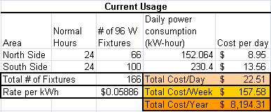
Current totals with highest rate ($0.20502):
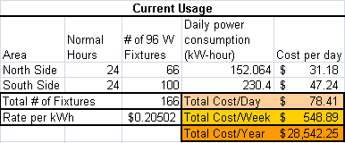
It is from these price points that savings can be achieved.

Potential Savings
If the North and South offices are divided into zones as shown in the above diagrams, the savings in the figures below can be realized. Having multiple switches allows for more controllable electricity consumption and makes these savings possible.
These figures were calculated using the data from the survey taken of employee’s typical working hours. If lights are turned off when an area is not in use, then the savings below can be realized. Again, the electrical costs for both extreme rate possibilities have been calculated.
Overall totals with lowest rate ($0.05886):
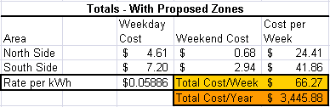
Overall totals with highest rate ($0.20502):
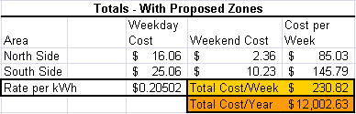
Savings possible with lowest rate ($0.05886):
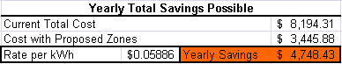
Savings possible with highest rate ($0.20502):
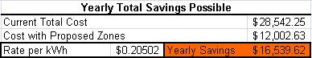

Again, it is to be emphasized that the yearly savings would be somewhere between these two extreme totals. Detailed breakdowns of the cost calculations per zone can be found in the Appendix.

Conclusion
Local re-wiring in conjuction with additional individual switches will provide the best solution for GCA. Allowing employees to adjust lighting on an as needed basis minimizes energy usage while also introducing little to no impact on productivity. The relatively low cost in making the proposed changes in addition to the year over year cost savings allows the company to make a solid financial decision while embracing a greener vision for the company’s energy consumption. However, the initiatives envisioned by this proposal will only be fully realized if energy savings is a company-wide goal that insists on individual responsibility to minimize energy consumption.

List of Sources

http://www.energystar.gov/index.cfm?c=sb_guidebook.sb_guidebook_lighting
http://www.nvenergy.com/company/rates/snv/schedules/images/Statement_Rates_South.pdf

Appendix: Detailed Cost Calculations of Proposed Zones
North Side totals with lowest rate ($0.05886):
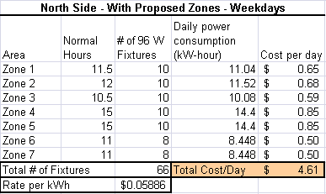
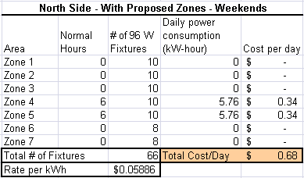
South Side totals with lowest rate ($0.05886):
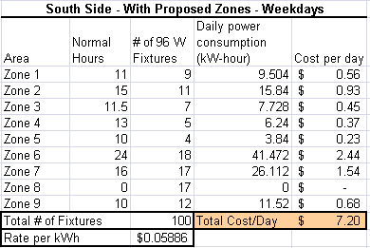
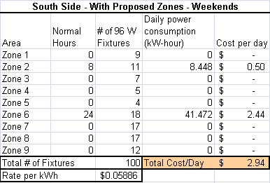
North Side totals with highest rate ($0.20502):
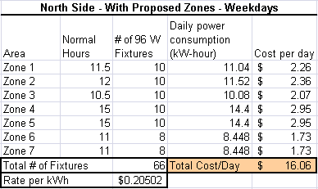
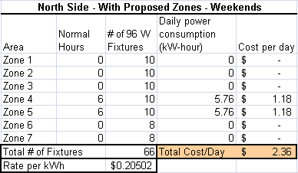
South Side totals with highest rate ($0.20502):
